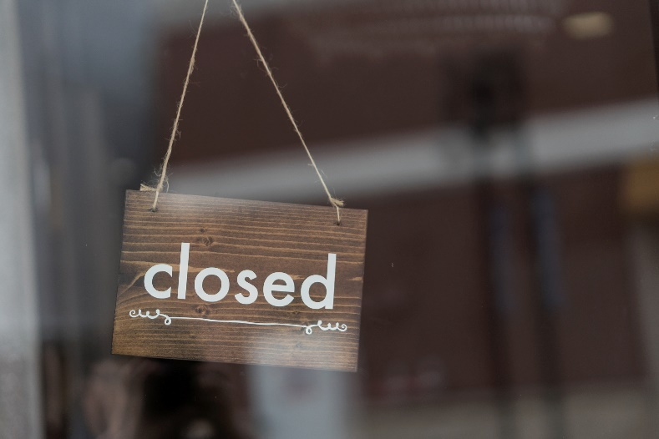
DS Custom Toolboxes will be closed Thursday the 26th of January for the Australia Day public holiday.

